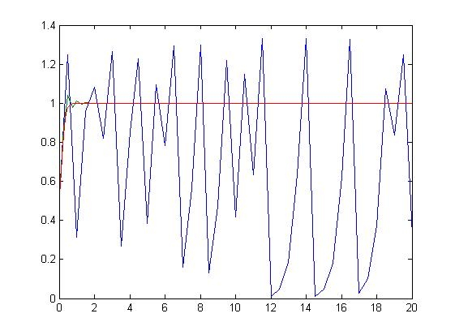
Figure 3.1 Forward Euler Method: —h=0.5, —h=0.25, —h=0.1
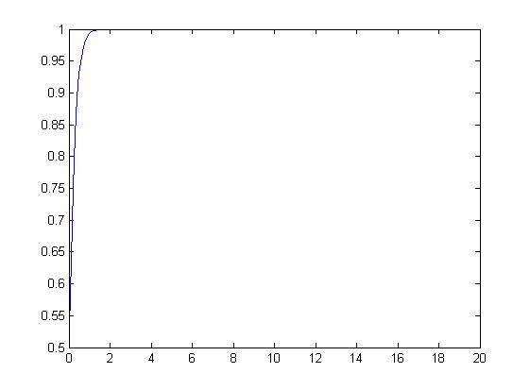
Figure 3.2 Backward Euler Method: —h=0.1
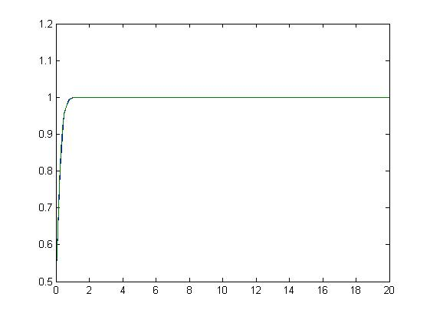
Figure 3.3 C-N Method: —h=0.25, —h=0.1
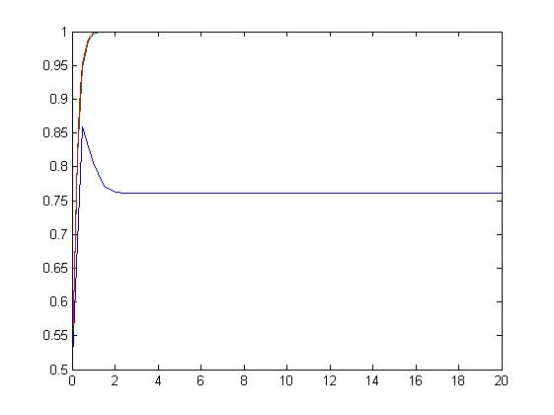
Figure 3.4 RK4 Method: —h=0.5, —h=0.25, —h=0.1

